Compiling BMElib using : Intel Visual Fortran 11.1 (with Microsoft Visual C++ 2008 SP1 linker)
- Set the BMElib Directory as current folder and then set “mvnlib” folder to MATLAB working DIRECTORY 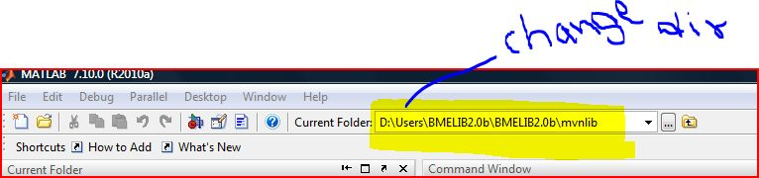

- Set compiler ( make compiler ready to use it) 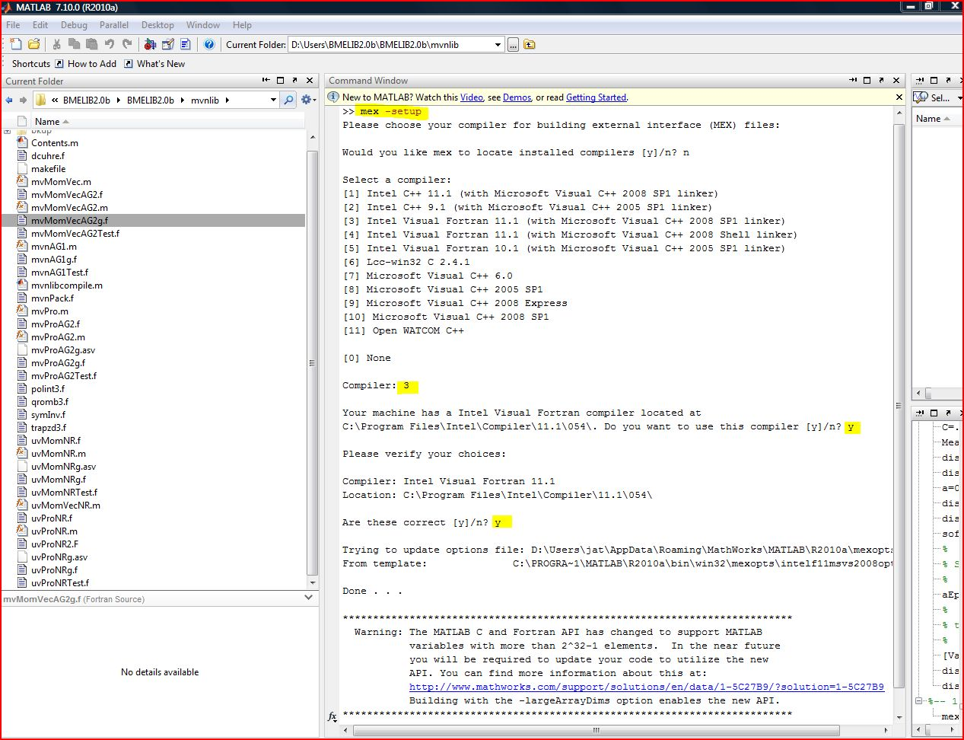
- Compile “mvnlibcompile” function
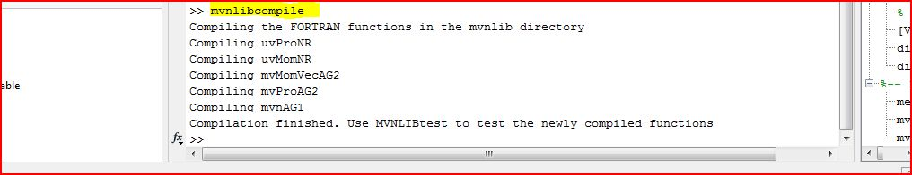

- Test all functions in “mvnlib” to make sure Fortran Compiler generated “*.mex32” files successfully 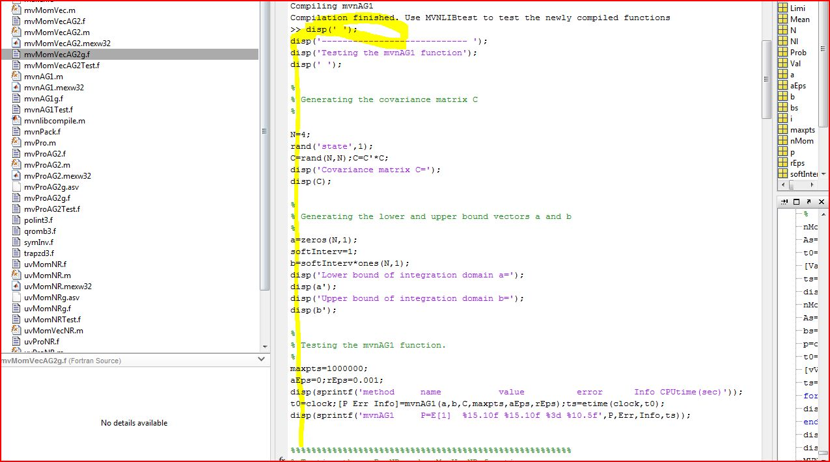 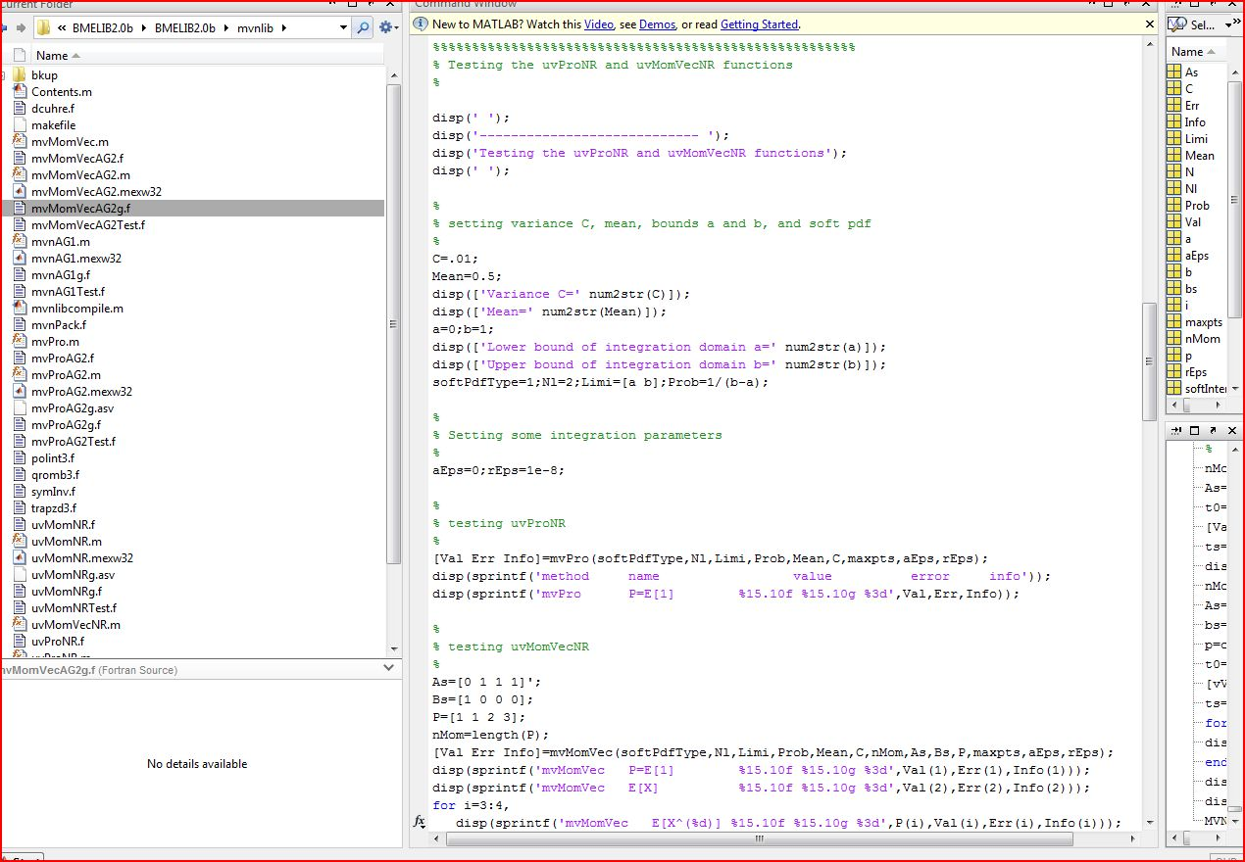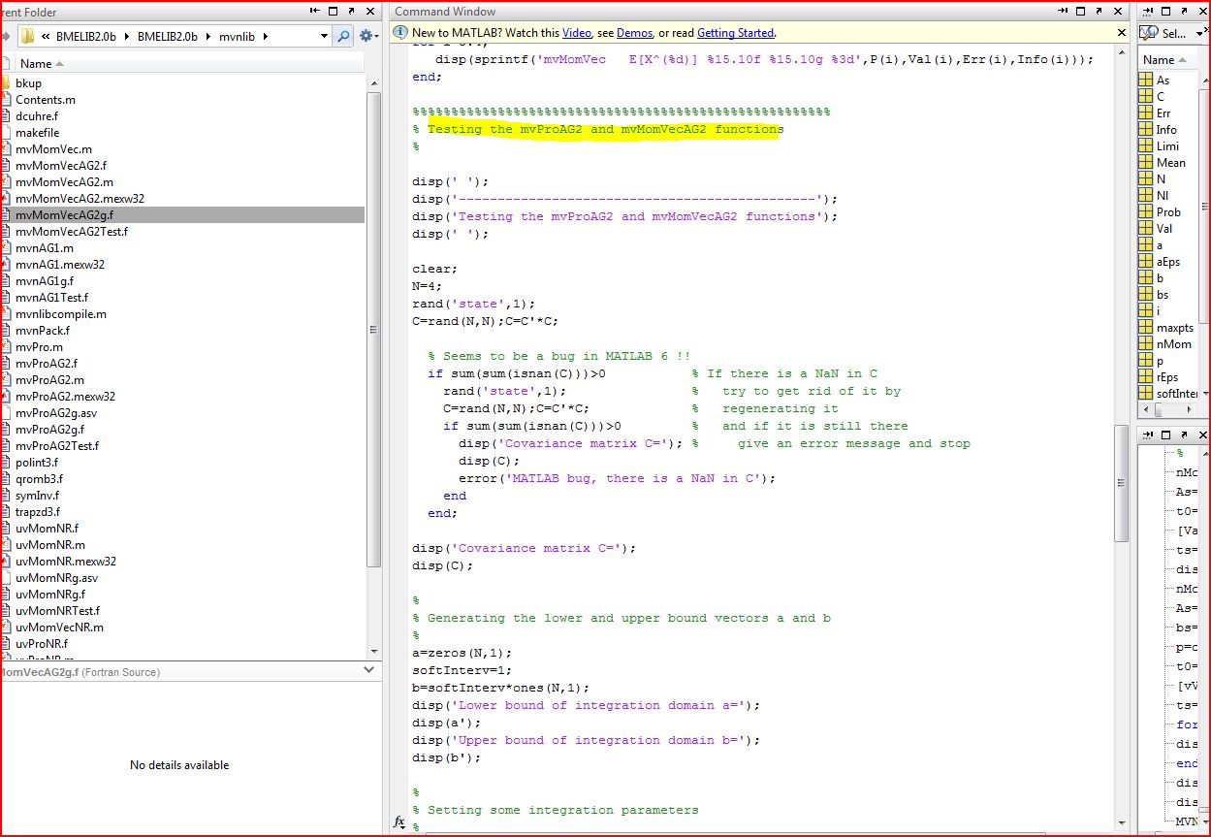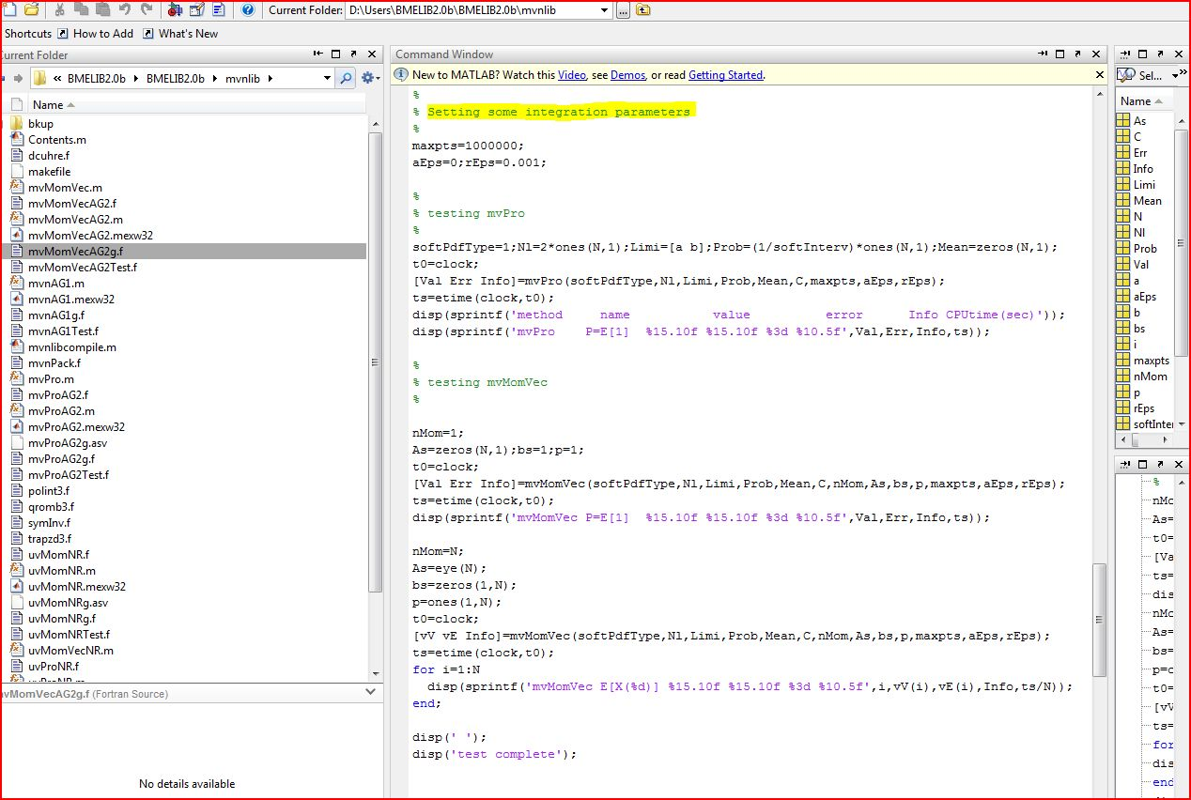
- Check RESULTS after executing “MVNLIBtest” (*.mex32” files) in MATLAB 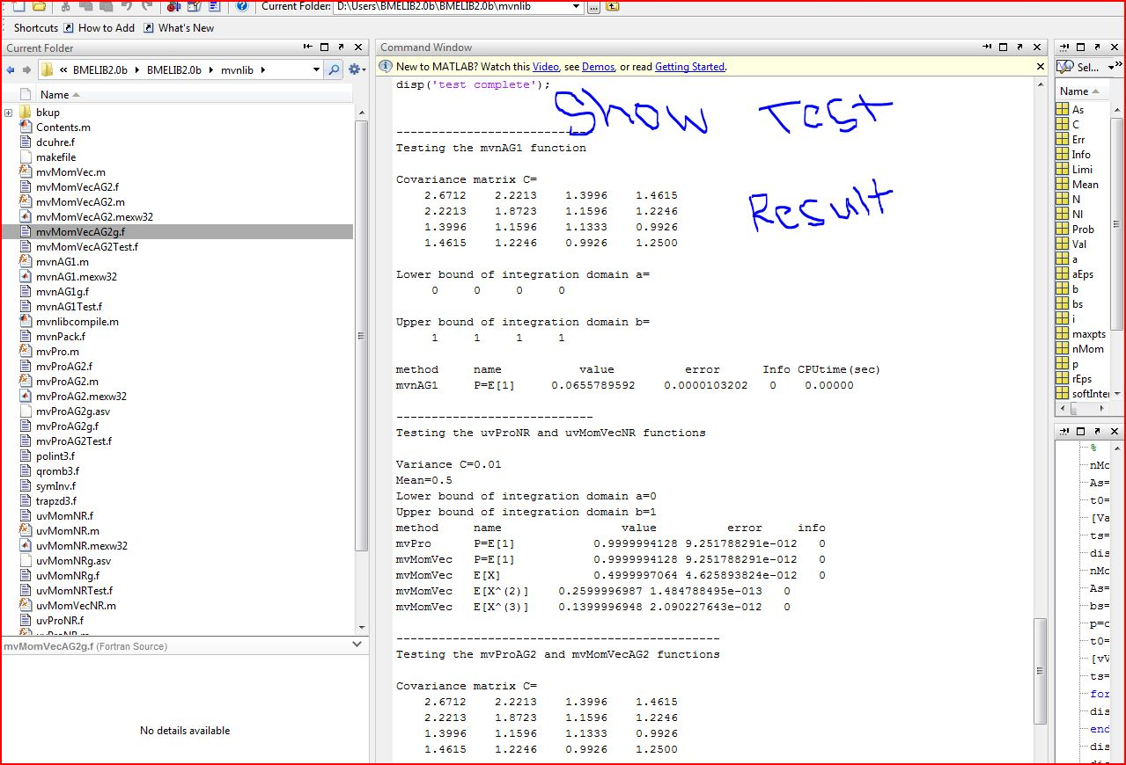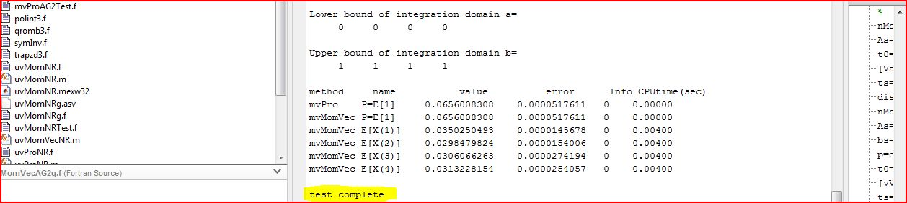

BINGO!!!!!!!!!!!!!!!!!!!!!!!!!!!!!!!!!!!!!!!!!!!!!!!

